Job Aid 2: Audit Preparation Guide ⁴⁻⁵⁸
Step #1 – Understand the scope of the audit
- Ensure the scope clearly defines the applicable standards, as well as the sections (clauses, SLIPTA tic boxes) of the standards that apply to the audit.
Step #2 – Review applicable standards
- When studying the standards, highlight the word shall each time it appears.
  - This signals your attention to focus on one requirement at a time. Pause and ensure you understand the requirement before continuing your studies.
  - Highlighting makes it easier to verify that the processes conform to all requirements of the standard.
- If a requirement remains unclear, then seek clarification from the audit coordinator.
Step #3 – Review applicable documentation
- Begin with the quality manual because it describes the processes and the interaction of those processes used at the site.
  - Look to see if the requirements were incorporated into the process during the planning phase for that process.
- Read, study and take notes on any applicable SOPs.
  - Determine if the SOPs are understandable from the perspective of a new hire (document review for adequacy).
  - Highlight the following areas in the SOP to incorporate into your checklist
    - Wishful thinking on the part of management (i.e. the following 15 signatures are required to ….)
    - Inconsistencies that occur when the process was changed but the documentation was not updated to reflect that change.
    - Points to verify during the audit (i.e. the water bath temperature is checked every 4 hours and recorded).
    - Responsibilities and authorities
      - Areas not clearly defined as to who is responsible for performing the task.
      - May assist with whom you want to interview during the audit.
    - Names of the records used by the auditee.
  - Review blank forms to understand the process and the type of documentation that will be reviewed during the audit.
- Verify that the documents (uncontrolled copies that are clearly indicated as such) you review are readily available, properly approved, and the latest version. You may need to speak to the Document Control Coordinator to verify this information during your document review (also known as a desk review).

Step #4 - Prepare a process model
- Select a process to begin building your model.
- Identify the desired output of the process.
- Identify the process owner.
- Identify the inputs of the process (WHO, INFORMATION, and WHAT). All documents used in the document review should be listed under INFORMATION. If no items apply to the WHAT box, then note non-applicable.
- Identify the records produced.
- Given the desired results of the process, identify applicable METRICS.

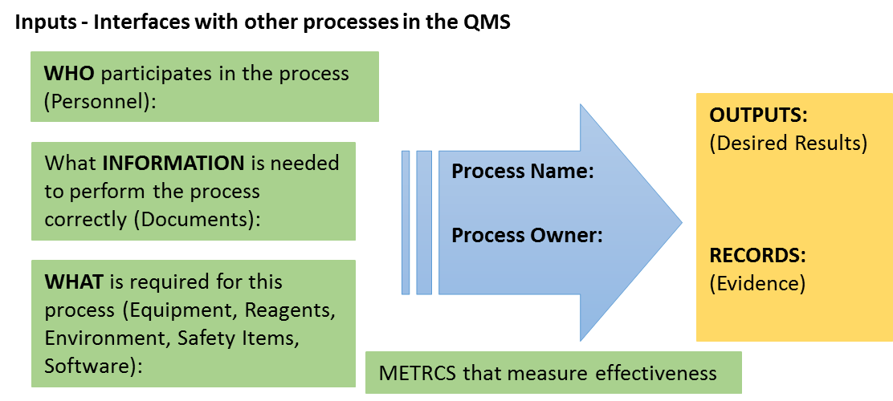

Step #5 - Review previous audit reports
You may be asked to determine the effectiveness of corrective action taken from a nonconformity discovered during a previous audit.
Step #6 – Create an effective checklist
- Beginning with the foundational all-process checklist, eliminate questions that do not apply to the process being audited.
- Rework each question on the checklist to incorporate the laboratory’s specific terminology.
- Add questions to the checklist from the document review and review of previous audits.
- Add the appropriate SLIPTA checklist items.
- Define your sampling plans to collect data (evidence)
- Create the needed audit matrices to collect and record data for the specific records that you plan to pull (sample) during the audit.

Step #7 – Attend the audit preparation meeting to complete your preparation
  - The internal audit coordinator or team leader should review each auditor’s checklist to ensure they have prepared (i.e. highlighting, customization) and have a working knowledge of the checklist.

