Handout 1: RCA Model ⁴⁻¹⁷
A Resource Guide to the RCA Process

RCA Phases | Improvement Model | ISO 15189  Clause 4.10 Corrective Action

Act

Plan
Do
Study
Diagnostic Phase
(finding the root cause)
1. Define the problem
2.
Understand the process
- Identify possible causes
- Collect evidence to confirm or deny each cause
- Determine the root cause(s)
- Reviewing nonconformities

- Determining the root causes of nonconformities

Solution Phase (removing the cause(s) of the problem)
6.
Identify possible solutions
7.
Select solution(s) to be implemented
8.
Implement solutions
- Evaluate the effects

- Institutionalize the change
- Evaluating the need for corrective action to ensure that nonconformities do not recur
- Determining and implementing corrective action needed
- Recording the results of corrective action taken
- Reviewing the effectiveness of the corrective action

Diagnostic Phase

Step | Activity | Deliverable
1 | Define the problem | Problem statement
In order to define the problem, you must first have initial information. If you did not receive sufficient information from the NCE report, then you must collect information so that you can define:
- What exactly is the problem? A description of what happened (that shouldn't have) or didn’t happen (that should have).
- Where does the problem occur? What places often indicate the causes and dictate how the problem must be solved.
Where? This element can refer to a geographic location or a process step.
- Who experiences the problem? It is important to know who experiences the problem so that the circumstances can be further explored. The people identified are usually the ones you need to interview.
- When does the problem occur? Interviews and data analysis are often key in determining the timing of the problem.
- How often does the problem occur? Frequency helps clarify the scope and magnitude of the problem. Frequently, the element chosen to measure is a symptom of the identified problem.
- Why does it matter? For a problem to exist, a standard, requirement or expectation must be violated. The so what element is the reason the problem is a concern.
Find how people’s assessments and actions made sense at the time given the circumstance that surrounded them. Techniques to better understand their perspective include:
- Observing the problem yourself;
- Interviewing;
- Analyzing documents and records;
- Photographing the problem;
- Reviewing previous NCE reports of a similar nature.
Always note where you are obtaining the information in case you must revisit it at a later time.

Note: A NCE from an audit is not a problem statement. Audits only provide evidence that the problem exits. It is up to the site to determine the extent of the problem.

A problem well stated is a problem half solved; therefore, a good problem definition can help make the diagnosis more focused and productive.

A good problem statement:
- Refrains from using names;
- Remains emotionless – it doesn’t have passion, sympathy, blame, or outrage;
- Focuses on the gaps between what is and what should be since the gaps reflects a change or deviation from the requirement, norm, standard, or expectation
- Excludes the how or why the problem occurred (i.e. what the cause is) -it states the effect (what is wrong) and not why it is wrong;
- Avoids lack of, due to, because of, as a result of, and no statements since these imply solutions;
- Includes measurable (how often, how much, when) specific statements

Step | Activity | Deliverables
2 | Understand the process | Process flowchart
It is important to evaluate the problem within the context of the failed process. It is within this failed process that the first level cause resides. One of the best ways to utilize the process for problem solving is through a process flowchart and flowcharting what the actual process is (i.e. what normally happens). This visual recreation of the process provides a roadmap to understand and document the actual work flow and highlights areas to begin brainstorming higher level causes.
Reasons processes fail and create problems that require corrective action include the following:
- If management did not design the quality plan to successfully carry out the work, then staff will do what they perceive as necessary or sufficient to complete the task.
- Deviations happen either intentionally or unintentionally resulting from not following the quality plan as implemented.
To start flowcharting, fill in the process steps between the beginning and ending boundary of the process being studied. The ending boundary is where the NCE was detected. To define the beginning boundary, start with capturing the preceding 4-8 process steps. If information becomes available that the boundaries need expanding, then do so.
Flowcharts help identify data collection points or where you doubt the process is being followed. By identifying places where certain steps of the process can be evaluated for how well they are working, you will be better able to determining what data to collect and how to collect it. If process steps can be eliminated as problematic, the amount of time and data required for RCA will be reduced.
Refine the problem statement, if needed.
Understand the process first, then ask why; don’t try to identify problem causes until you fully understand the problem within the context of the current process.

Step | Activity |  | Deliverable
3 | Identify possible causes |  | List of possible causes you want to test
Develop theories about what is causing the problem by brainstorming (i.e. a creative process for generating a large number of ideas) as a team. Not all of these causes are of equal importance; some of them will be outlandish in the spirit of brainstorming, and some will only be loosely connected to the problem. Narrow the list by eliminating the unrealistic causes. Decide what theories (i.e. what cause and effect relationships) you want to test by focusing on the causes you can do something about.
Avoid superficial, people-centered causes. Using the 5 WHYs may help with moving beyond the superficial. |  | 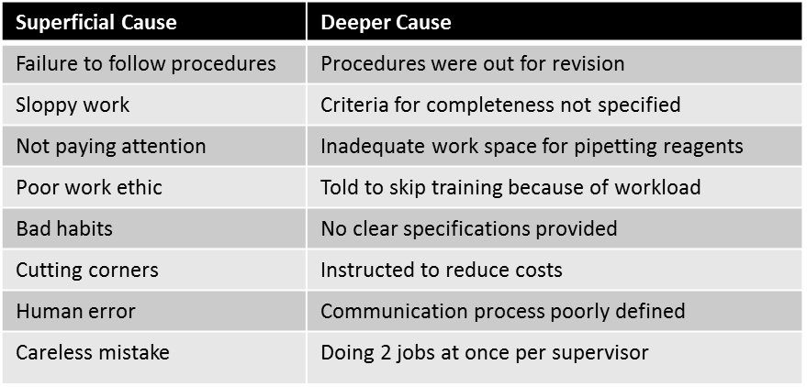
Common, idea-generating RCA tools used for this step are:
- Process step deviations - Review the processes that may have failed with a should-be flowchart, then look at the deviations that may have occurred that caused the problem.
- Logic Tree- Create an organizational chart of causes that allows drilling down into the higher level causes by asking why.
- Fishbone Cause and Effect Diagram –Generate and then group causes into general categories.
- Change Analysis – When the change is a sudden, significant shift in performance at some point in time, then compare what the problem is and is not about.
Problems rarely have one easily identifiable cause. Finding the root cause takes creativity.

Step | Activity | Deliverable
4 | Collect evidence to confirm or deny each suspected cause. | Data analysis summaries
Collect data - not just numbers, but any information one can use to evaluate in order to improve the probability of making a good decision. Data comes in 2 forms: quantitative data (i.e. anything numeric or counted) and qualitative data (i.e. something heard or observed). Remember, some of the data needed may already be available.
Decisions regarding sample size and timeframe need to be considered. The data collection plan must specify how many samples are necessary in order to provide an adequate level of confidence, as well as, time frame especially when there are cyclic variations or peak/trough output times.
Data collection tools include interviews, direct observations, record reviews, pictograms, surveys, and tally sheets. How to collect good data
  - Determine where in the process the causes can be or should be measured;
  - Know what form the data will be in and decide when and how they should be gathered
  - Predict what the data will look like if each factor is or is not the cause, and decide how they will be analyzed to evaluate the evidence
  - Prepare for the data collection process
      - Develop a table that spells out the data collection plan
Causes to evaluate | Data source | Sample size | Time frame | Who will collect | How data will be analyzed
Equipment Malfunction | Maintenance & service records | all | Past 6 months | Section supervisor | Tally sheet
    - Determine the forms that may need to be created
    - Communicate the plan and how to use the form to the appropriate people
Analyze data - make a determination which causes did or did not contribute to the problem. Find out what relationship exists, if any between the cause(s) believed to affect the outcome described in the problem statement. The next step is to decide whether the level of cause that has been identified is one where action can and should be taken (continue to step 5), or whether a deeper analysis is warranted (return to step 1). Realize that it is usually easier to prove something is not the cause than to prove that it is. Common tools used to analyze data include histograms (bar charts), Pareto charts, scatter charts, and problem concentration diagrams.
If multiple independent causes at a particular level align to cause the problem, the RCA team must make a decision if it should work on all causes or instead focus on the one(s) having the greatest impact. This doesn’t mean the other causes will be ignored, but once the largest cause is eliminated, the decision can be made whether to move on to the next largest contributing cause. By deciding whether to work on all issues or only the largest helps to scope (boundary range) the problem to be addressed by the organization.

Data reduces uncertainty and removes emotion.

Step | Activity | Deliverable
5 | Determine the root cause(s) | Root cause statement
The identified root cause(s) defines the RCA team’s findings about what must be fixed. There is rarely only one underlying root cause due to the complexity and interrelationships involved in a laboratory’s QMS. The Solution Phase that follows is completely guided by the identified root cause(s) determined in this step.
When developing a root cause statement, ask If we control or eliminate this cause, will we prevent or minimize the problem (effect)? The root cause statement should not blame or single out an individual.
The following guidelines need to be considered when developing the team's root cause statement:
- Clearly show the cause and effect relationship. The link between the root cause and the bad outcome must be clearly shown so that all readers understand the RCA’s team logic in linking this cause with the outcome.
- Use specific and accurate descriptors for what occurred, rather than negative and vague words.
      - Negative descriptions merely serve as a placeholder for the needed accurate and clear description required.
      - Words to avoid include poorly, inadequately, haphazardly, improperly, carelessness, complacently, badly
- Identify the preceding cause(s), not the human error. It is the cause of the error and not the error itself that leads to productive strategies to reduce or eliminate the error.
- Identify the preceding cause(s) of procedure violations (i.e. WHY was the procedure not followed)
- Failure to act is only a root cause when there is a pre-existing duty to act. It is inappropriate to hold staff accountable for activities that have not been communicated. An employee’s failure to perform a specific task can only be causal if they were initially required to perform the task.

Armed with information, you can begin to develop a realistic and viable plan to correct the problem and prevent
recurrence – going onto the next phase
Solution Phase

Step | Activity | Deliverable
6 | Identify possible solutions | List of possible solutions
Brainstorming is an excellent tool to generate a list of possible solutions. It is important that the RCA team not place limits on ideas thought to be viable during the brainstorming session. Frequently these constraints are imagined rather than real and will inhibit the out-of-the-box ideas to surface.
Solutions according to their strength in preventing recurrence:
- Stronger solutions - physical changes to the environment or process; standardize or simplify the process; mistake-proofing
- Intermediate- job aids, reduce similar items/language/locations/distractions so that it is easy to do the right thing
- Weaker – trainings(either the individual had not been trained or it was ineffective; then the reason for the ineffectiveness must be found and addressed), warnings (oral or written), adding another check

Step | Activity | Deliverables
7 | Select solution(s) to be implemented | Workable solution to the problem being studied AIM statement  Baseline Effectiveness Data
The solutions must be sorted through to identify the one(s) to be implement by determining:
- Who should make the decision?
- What criteria should be used to make it?
      - Strength of Solution
      - Benefit-to-cost ratio
      - Length of time to implement
      - Other problems the solution might create

If a decision cannot be made, then consider the simplest solution. Frequently, a more complex solution may be more costly, more difficult to implement, and less predictable.
Define an AIM statement that answers the overall goal you want to achieve. This AIM statement should be SMART (specific, measurable, attainable, realistic, time-bound). The measurable component should focus on the effectiveness of solution and not the steps in the process related to implementing that solution. Ensure the team is clear as to how or why the solution will achieve the AIM. During this step, you should define and design your measure of effectiveness that your team will use in comparison with post implementation data. If previously collected data from an earlier step will suffice for the baseline effectiveness data, then you may choose to use it.
The solution chosen should:
- Have a strong sense of being successfully implemented;
- Will be accepted by all relevant stakeholders;
- Address the root cause determined.
You will need to first sell the team’s selected solution to all stakeholder first before implementing the solution to obtain the needed buy-in.
How to sell the solution to key stakeholders.
- Sell the benefit to the audience
- Provide alternative solutions to show why your solution is superior, be specific
- Outline the project plan to decision makers – show that the effective path has already been determined, the team just needs the go-ahead from them.

Step | Activity | Deliverables
8 | Implement Solutions | Project plan  Post implementation data
Implementing the changes that are required to reach a lasting solution involves project management. Project management is basically creating the schedule for implementation, acquiring and organizing the resources, communicating, and carrying-out the action plan. Part of the communication must address change resistance, so consider ways to reduce or mediate this so that the change will be more successful and less stressful. Sometimes the process of carrying-out the implementation may be performed by different people from the ones who planned for its implementation; therefore, communication is key.
Successful implementation includes:
- Organizing the implementation;
- Developing an implementation plan;
      - Required activities
      - Activity sequence
      - Organization and responsibility
      - Schedule including due date
      - Forward scheduling – one predicts how long each activity of the project will take and then schedules out to determine when the project will be completed
      - Backward scheduling – sets a data by which the project is to be completed, and then sets schedule and allocates resources for each activity in order to accomplish it
  - Costs
  - Resources required
  - Measure of effectiveness
- Creating acceptance of the required changes and a favorable climate for implementation;
- Carrying-out the implementation.
- Reviewing progress regularly
- Updates provided to management by team leader
A common tool used for project management is a Gantt chart. Gantt charts make it easy to visualize project management timelines by transforming task names, start dates, durations, and end dates into cascading horizontal bar charts.

Finding a good solution is one thing, but effectively implementing it is another.
9

Step | Activity | Deliverable
9 | Evaluate the effects | Verification results and analysis
Seek evidence that the solutions were effective in removing or reducing the causes they were designed to address. Effectiveness has an element of measurability; when you have removed the cause, monitor the symptoms to help ensure that the problem will not recur. First look at the outcome variable being monitored to see whether performance of the process is back to what is normal or expected based on the AIM statement. Then check the solution variable to ensure the change had been properly implemented.
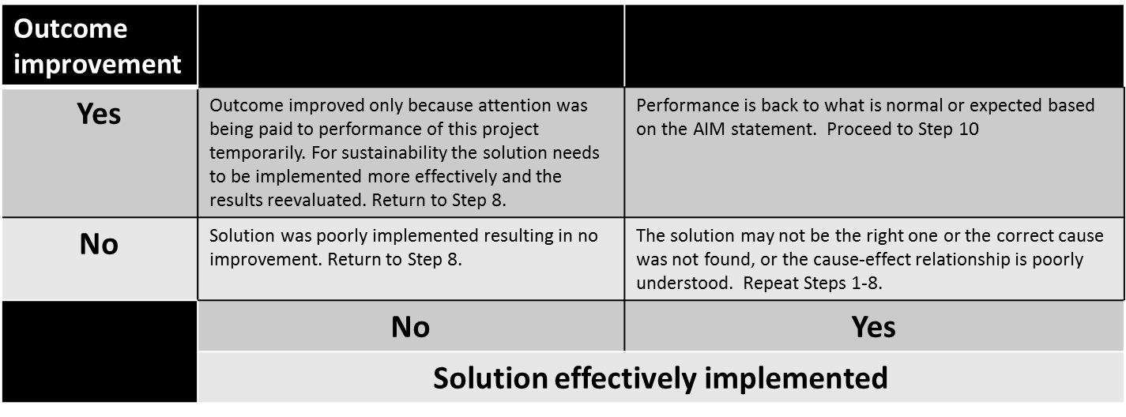

During this step, look for any adverse or unplanned results due to the solution being implemented. Remember, an effective evaluation approach may include a variety of information or data sources, such as feedback, direct observation, audit results, and quality indicator data. For example, determine if affected employees are knowledgeable about the changes. Speak to staff in the work areas and determine if they are familiar with the changes and their roles in implementing them.
To justify your conclusions regarding effectiveness, include an interpretation (i.e. what the findings mean), judgement (i.e. the merit or worth of the implemented solution compared with the AIM statement), and recommendations (i.e. actions for consideration resulting from the analysis).
Did the selected solution work a predicted?
10

Step | Activity | Deliverable
10 | Institutionalize the change | Close-out report and meeting
Assuming the expected results were achieved, sustaining the improvement and related knowledge must be maintained. First, standardize the change. Remember to update any documents that weren’t revised prior to implementation, such as job descriptions, training material content, databases. Next spread what was learned to other areas/processes/facilities that has the potential for the problem to occur or where the solution would improve performance. Ensure changes are communicated to all affected personnel. Make it impossible to return to the old way of doing things and include adoption of change as a component of personnel evaluations (i.e. how well does this employee embrace this management-directed change). To sustain the gain over the long term, consider formal tracking of the outcome, such as a quality indicator, for some longer period of time. Audit the changed process to ensure the desired process controls are being properly maintained.
Consider how to transfer project ownership from the RCA team to the owner of the process, who may have little knowledge of the rationale behind the conclusions made regarding the implemented solution. This way, the process owner takes responsibility with QA personnel providing coaching to ensure quality is sustained.
Prepare a close-out report that:
- Defines the problem;
- Summarizes what happened (i.e. event summary);
- Explains why it happened (i.e. the cause of the event);
- Notes the corrective action taken and any recommendations forthcoming.

Present the findings during a close-out meeting. Present not only conclusions but also a portion of the process to arrive at those conclusions so that:
- Listeners better understand that the conclusions were not arbitrary but reached by a logical objective process. Comprehension by staff makes it harder for them to revert back to the old way of doing things.
- A teaching moment about the steps for conducting an effective diagnosis is not missed.
Retain all documents and records related to the corrective action according to your site’s retention schedule. Remember to celebrate and communicate your continual improvement activities to hospital management.

The corrective action is considered successful only when the solution is integrated and sustained.

