The Model for Improvement (MFI) ^{XC 04}
A simple, yet powerful approach, using formal methods to test changes in the steps of a process, to achieve rapid and significant improvements (IHI, Model for Improvement).

The Model for Improvement consists of two components, which follow each other sequentially:
Part I | Answers to Three Fundamental Questions leading to the project Goals/Aim, Metric and Change
Part II | The Plan-Do-Study-Act (PDSA) Cycle, the iterative scientific method for achieving improvement through testing change, i.e., altering a step in a process and evaluating the impact of that alteration

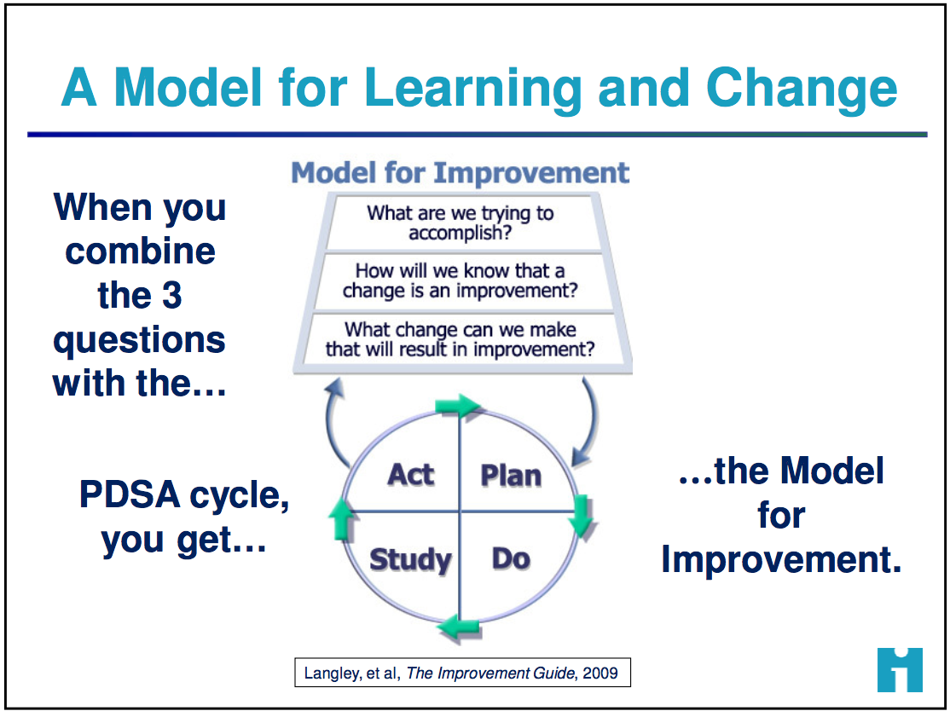

PART I: The Three Fundamental Questions

Three Fundamental Questions | Deeper/Probing Questions | Desired Output
- What are you trying to accomplish? | - What outcome, in measurable terms, are you hoping to accomplish?  - Specify how good, for whom, and by when. | Goals and Aim Statement  Overarching, “big picture” goal initially; then hone to an aim statement with a specific, measurable, time-bound outcome
- How will you know if a change is an improvement? | - What would be the most useful, meaningful metric to track?  - What metric provides the best measure of desired goal? | Metric  A metric to complete the aim statement; Define the numerator and denominator for your metric
- What change will you make that will result in an improvement? | - Which changes will lead to the most significant improvement?  - Which changes will promote reaching the aim? Improve the metric? | Change/Intervention  Based on insights gained during process mapping, begin small tests of change, ultimately describing, selecting, and taking the best intervention to scale.  Small tests of change allow rapid testing of various solutions before adopting the best intervention to address the root or underlying cause

Tips:
- Engage the team and stakeholders in determining the overall goal; i.e., what you want to accomplish.
- Answering question #1 and #2 is an iterative process, with each round gaining additional clarity and specification toward creating an AIM Statement
- When asked, everyone on the team should know the aim statement and elevator speech

PART II: The Plan-Do-Study-Act (PDSA) Cycle - Tests of Change Cycles

PLAN | - State the objective  - Make predictions  - Generate solutions  - Develop a data collection plan (who, what, where, when) | Tips:  - PDSA is not ‘one and done’, it consists of multiple iterative cycles. Think ahead & plan for the multiple cycles of testing over a wide range of conditions, collecting useful data from each test to guide the next one.  - Start small - Focus the initial test on the “one” – one doctor, one nurse, one laboratorian, one shift, one form, one day, etc.  - Start - Don’t wait around. Ask, “what change can we test by next Tuesday?”  - Keeping PDSA cycles updated on the Learning Board ensures that all involved know what changes are being tested
DO | - Run the test on a small scale  - Document problems & observations  - Collect and chart the data
STUDY | - Analyze the data  - Compare data to predictions  - Summarize learnings
ACT | - Determine what modifications you should make – adapt, adopt, or abandon  - Standardize the process  - Select the next cycle

Moving from the small test of change to widespread “big” change using ever widening PDSA Cycles
- Begin with small tests of change - focus on the “one”. As one PDSA cycle is complete, the next cycle begins.  - Continue to fine-tune tests – use lessons learned to “tweak” the test, and with each cycle, the involvement expands to involve another person/s, another shift, etc.  - Conduct wider scale tests - involve another group, another unit, another facility, etc.  - Standardize/Implement - When the change is proven to work reliably, it then becomes the new way to do work. The change is standardized into a new process and implemented.  - Move to the Control phase - where the change is monitored for sustainability and results are shared  - Implement at scale – if the change is applicable, it may be spread to other facilities or organizations | 