LQMS Content Sheet
Content Sheet 6-1: Process Control—Introduction to Quality Control

Role in quality management system | Process control is an essential element of the quality management system, and refers to control of the activities employed in the handling of samples and examination processes in order to ensure accurate and reliable testing. Sample management, discussed in Module 5, and all quality control processes are a part of process control.  Quality control (QC) monitors activities related to the examination (analytic) phase of testing. The goal of quality control is to detect, evaluate, and correct errors due to test system failure, environmental conditions, or operator performance, before patient results are reported. | Organization  Personnel  Equipment  Purchasing  &  Inventory  Process Control  Information Management  Documents  &  Records  Occurrence Management  Assessment  Process Improvement  Customer Service  Facilities  &  Safety
What is QC? | Quality control is the part of quality management focused on fulfilling quality requirements (ISO 9000:2000 [3.2.10]). Simply put, it is examining “control” materials of known substances along with patient samples to monitor the accuracy and precision of the complete analytic process. QC is required for accreditation purposes.  In 1981, WHO used the term ‘Internal Quality Control’ (IQC), which it defined as “a set of procedures for continuously assessing laboratory work and the emergent results.” The terms QC and IQC are sometimes used interchangeably; cultural setting and country may influence preferences for these terms.  In the past few years, the term ‘internal quality control’ has become confusing in some settings because of the different meanings that have been associated with the term. Some manufacturers of test kits for qualitative tests have integrated ‘built-in’ controls into the design of their kits, which they sometimes refer to as internal controls. Other manufacturers include their own control materials with the kits they sell, and they refer to these as ‘internal controls,’ meaning that the materials are meant specifically for that manufacturer’s kit. Finally, some people refer to any quality control materials that are used in conjunction with test runs as IQC, as in the 1981 WHO definition  To avoid confusion, the term ‘quality control’ will be used here to mean use of control materials to monitor the accuracy and precision of all the processes associated with the examination (analytic) phase of testing.

QC for varying methods | Quality control processes vary, depending on whether the laboratory examinations use methods that produce quantitative, qualitative, or semi-quantitative results. These examinations differ in the following ways.  Quantitative examinations measure the quantity of an analyte present in the sample, and measurements need to be accurate and precise. The measurement produces a numeric value as an end-point, expressed in a particular unit of measurement. For example, the result of a blood glucose might be reported as 5 mg/dL.  Qualitative examinations are those that measure the presence or absence of a substance, or evaluate cellular characteristics such as morphology. The results are not expressed in numerical terms, but in qualitative terms such as “positive” or “negative”; “reactive” or “non-reactive”; “normal” or “abnormal”; and “growth” or “no growth”. Examples of qualitative examinations include microscopic examinations, serologic procedures for presence or absence of antigens and antibodies, and many microbiological procedures.  Semi-quantitative examinations are similar to qualitative examinations, in that the results are not expressed in quantitative terms. The difference is that results of these tests are expressed as an estimate of how much of the measured substance is present. Results might be expressed in terms such as “trace amount”, “moderate amount”, or “1+, 2+, or 3+”. Examples are urine dipsticks, tablet tests for ketones, and some serological agglutination procedures. In the case of other serologic testing, the result is often expressed as a titer – again involving a number but providing an estimate, rather than an exact amount of the quantity present.  Some microscopic examinations are considered semi-quantitative because results are reported as estimates of the number of cells seen per low power field or high power field. For example, a urine microscopic examination might report 0-5 red blood cells seen per high power field.  Because quality control processes differ for these various types of examinations, the presentations for QC will be divided into two modules. Module 7 will address QC for quantitative examinations, and Module 8 will address QC for qualitative and semi-quantitative examinations.
Elements of a  QC program | Regardless of the type of examination that is performed, steps for implementing and maintaining a QC program include:  - 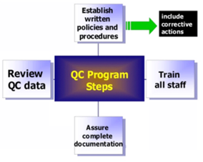establishing written policies and procedures, including corrective actions;  - training all laboratory staff;  - assuring complete documentation;  - reviewing quality control data.  These responsibilities will be described in more detail in Modules 7 and 8.
Summary | - QC is part of the quality management system, and is used to monitor the examination (analytic) phase of testing.  - The goal of QC is to detect, evaluate, and correct errors due to test system failure, environmental conditions, or operator performance, before patient results are reported.  - Different QC processes are applied to monitor quantitative, qualitative, and semi-quantitative tests.

Content Sheet 7-1: Overview of Quality Control for Quantitative Tests

Role in  quality management system | Quality Control (QC) is a component of process control, and is a major element of the quality management system. It monitors the processes related to the examination phase of testing and allows for detecting errors in the testing system. These errors may be due to test system failure, adverse environmental conditions, or operator performance. QC gives the laboratory confidence that test results are accurate and reliable before patient results are reported.  This module explains how quality control methods are applied to quantitative laboratory examinations. | Organization  Personnel  Equipment  Purchasing  &  Inventory  Process Control  Information Management  Documents  &  Records  Occurrence Management  Assessment  Process Improvement  Customer Service  Facilities  &  Safety
Overview of  the process | Quantitative tests measure the quantity of a substance in a sample, yielding a numeric result. For example, the quantitative test for glucose can give a result of 110 mg/dL. Since quantitative tests have numeric values, statistical tests can be applied to the results of quality control material to differentiate between test runs that are “in control” and “out of control”. This is done by calculating acceptable limits for control material, then testing the control with the patient’s samples to see if it falls within established limits.  As a part of the quality management system, the laboratory must establish a quality control program for all quantitative tests. Evaluating each test run in this way allows the laboratory to determine if patient results are accurate and reliable.
Implementation process | The steps for implementing a quality control program are:  - to establish policies and procedures;  - to assign responsibility for monitoring and reviewing;  - to train all staff how to properly follow policies and procedures;  - to select good quality control material;  - to establish control ranges for the selected material;  - to develop graphs to plot control values; these are called Levey-Jennings charts;  - to establish a system for monitoring control values;  - to take immediate corrective action if needed;  - to maintain records of quality control results and any corrective actions taken.
Content Sheet 7-2: Control Materials

Defining control materials | Controls are substances that contain an established amount of the substance being tested– the analyte. Controls are tested at the same time and in the same way as patient samples. The purpose of the control is to validate the reliability of the test system and to evaluate the operator’s performance and environmental conditions that might impact results.
Differentiating controls and calibrators | It is important not to confuse calibrators and control materials.  Calibrators are solutions with a specified defined concentration that are used to set or calibrate an instrument, kit, or system before testing is begun. Calibrators are often provided by the manufacturer of an instrument. They should not be used as controls since they are used to set the instrument.  Calibrators are sometimes called standards, but the term calibrator is preferred. They usually do not have the same consistency as patients’ samples.
Characteristics of control materials | It is critical to select the appropriate control materials. Some important characteristics to consider when making the selection.  - Controls must be appropriate for the targeted diagnostic test–the substance being measured in the test must be present in the control in a measurable form.  - The amount of the analyte present in the controls should be close to the medical decision points of the test; this means that controls should check both low values and high values.  - Controls should have the same matrix as patient samples; this usually means that the controls are serum-based, but they may also be based on plasma, urine, or other materials.  Because it is more efficient to have controls that last for some months, it is best to obtain control materials in large quantity.
Types and sources of control material | 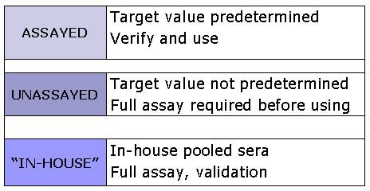  Control materials are available in a variety of forms. They may be frozen,  freeze-dried, or chemically preserved. The freeze-dried or lyophilized materials must be reconstituted, requiring great care in pipetting in order to assure the correct concentration of the analyte.  Control materials may be purchased, obtained from a central or reference laboratory, or made in-house by pooling sera from different patients.  Purchased controls may be either assayed or unassayed.  Assayed controls have a pre-determined target value, established by the manufacturer. When using assayed controls the laboratory must verify the value using its own methods. Assayed controls are more expensive to purchase than unassayed controls.  When using either unassayed or “in-house” or homemade controls, the laboratory must establish the target value of the analyte.  The use of in-house controls requires resources to perform validation and testing steps. An advantage is that the laboratory can produce very large volumes with exact specification.    Remember that quality control materials are usually serum-based. Universal precautions should be used when handling.
Choosing controls | When choosing controls for a particular method, select values that cover medical decision points, such as one with a normal value, and one that is either high or low, but in the medically significant range.  Controls are usually available in ‘high’, ‘normal’, and ‘low’ ranges.  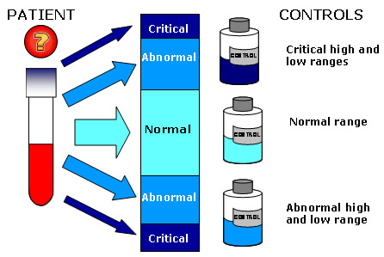  Shown in the graphic are normal, abnormal high and low, and critical high and low ranges.  For some assays, it may be important to include controls with values near the low end of detection.
Preparing and storing control material | When preparing and storing quality control materials it is important to carefully adhere to the manufacturer’s instructions for reconstituting and for storage. If in-house control material is used, freeze aliquots and place in the freezer so that a small amount can be thawed and used daily. Do not thaw and re-freeze control material. Monitor and maintain freezer temperatures to avoid degradation of the analyte in any frozen control material.  Use a pipette to deliver the exact amount of required diluent to lyophilized controls that must be reconstituted.
Content Sheet 7-3: Establishing the Value Range for the
Control Material

Assaying control over time | Once the appropriate control materials are purchased or prepared, the next step is to determine the range of acceptable values for the control material. This will be used to let the laboratory know if the test run is “in control” or if the control values are not reading properly – “out of control”.  This is done by assaying the control material repeatedly over time. At least 20 data points must be collected over a 20 to 30 day period. When collecting this data, be sure to include any procedural variation that occurs in the daily runs; for example, if different testing personnel normally do the analysis, all of them should collect part of the data.  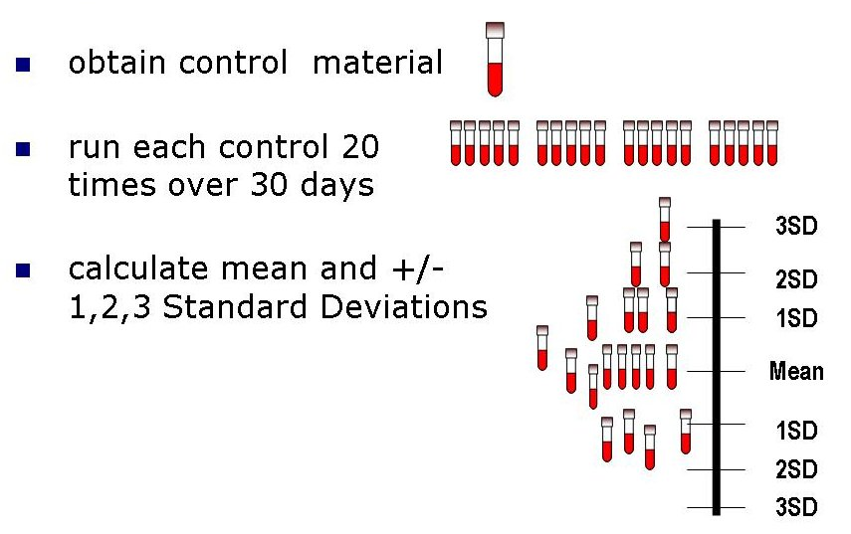  Once the data is collected, the laboratory will need to calculate the mean and standard deviation of the results.  A characteristic of repeated measurements is that there is a degree of variation. Variation may be due to operator technique, environmental conditions, and the performance characteristics of an instrument. Some variation is normal, even when all of the factors listed above are controlled. The standard deviation gives a measure of the variation.  One of the goals of a quality control program is to differentiate between normal variation and errors.
Characteristics of repeated measures | A few theoretical concepts are important because they are used to establish the normal variability of the test system. Quality control materials are run to quantify the variability and establish a normal range, and to decrease the risk of error.  The variability of repeated measurements will be distributed around a central point or location. This characteristic of repeated measurements is known as central tendency.  The three measures of central tendency are:  - Mode, the number that occurs most frequently.  - Median, the central point of the values when they are arranged in numerical sequence.  - Mean, the arithmetic average of results. The mean is the most commonly used measure of central tendency used in laboratory QC.
Statistical notations | Statistical notations are symbols used in mathematical formulas to calculate statistical measures. For this module, the symbols that are important to know are:
  ∑ | the sum of
  n | number of data points (results or observations)
  X₁ | individual result
  X_{1 -.} X_{n} | data point 1- n where n is the last result
   | the symbol for the mean.
   | the square root of the data.
Mean | The formula for the mean is:  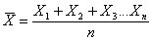  As an example of how to calculate a mean, consider ELISA testing. The method is to gather data as ratios, add the values, and divide by the number of measurements.
Before calculating QC ranges | The purpose of obtaining 20 data points by running the quality control sample is to quantify normal variation, and establish ranges for quality control samples. Use the results of these measurements to establish QC ranges for testing.  If one or two data points appear to be too high or low for the set of data, they should not be included when calculating QC ranges. They are called “outliers”.  - If there are more than 2 outliers in the 20 data points, there is a problem with the data and it should not be used.  - Identify and resolve the problem and repeat the data collection.
Normal distribution | If many measurements are taken, and the results are plotted on a graph, the values form a bell-shaped curve as the results vary around the mean. This is called a normal distribution (also termed Gaussian distribution).  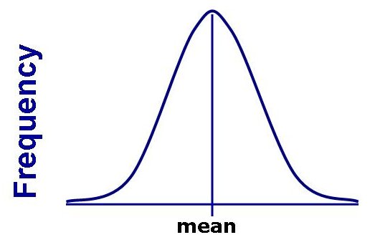  The distribution can be seen if data points are plotted on the x-axis and the frequency with which they occur on the y-axis.  The normal curve shown (right) is really a theoretical curve obtained when a large number of measurements are plotted. It is assumed that the types of measurements used for quantitative QC are normally distributed based on this theory.
Accuracy and precision | If a measurement is repeated many times, the result is a mean that is very close to the true mean.  Accuracy is the closeness of a measurement to its true value.  Precision is the amount of variation in the measurements.  - The less variation a set of measurements has, the more precise it is.  - In more precise measurements, the width of the curve is smaller because the measurements are all closer to the mean.  Bias is the difference between the expectation of a test result and an accepted reference method.  The reliability of a method is judged in terms of accuracy and precision.
Target illustration | A simple way to portray precision and accuracy is to think of a target with a bull’s eye.  The bull’s eye represents the accepted reference value which is the true, unbiased value. If a set of data is clustered around the bull’s eye, it is accurate.  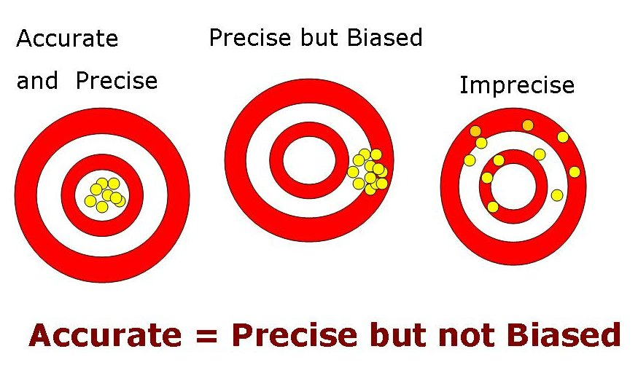  The closer together the hits are, the more precise they are. If most of the hits are in the the bull’s eye, as in the figure on the left, they are both precise and accurate.  The values in the middle figure are precise but not accurate because they are clustered together but not at the bull’s eye. The figure on the right shows a set of hits that are imprecise.  Measurements can be precise but not accurate if the values are close together but do not hit the bull’s eye. These values are said to be biased. The middle figure demonstrates a set of precise but biased measurements.  The purpose of quality control is to monitor the accuracy and precision of laboratory assays before releasing patient results.
Measures of variability | The methods used in clinical laboratories may show different variations about the mean; hence, some are more precise than others. To determine the acceptable variation, the laboratory must compute the standard deviation (SD) of the 20 control values. This is important because a characteristic of the normal distribution is that, when measurements are normally distributed:  - 68.3% of the values will fall within -1 SD and +1 SD of the mean  - 95.5% fall within -2 SD and +2 SD  - 99.7% fall between -3 SD and +3 SD of the mean.  Knowing this is true for all normally shaped distributions allows the laboratory to establish ranges for quality control material.  Once the mean and SD are computed for a set of measurements, a quality control material that is examined along with patients samples should fall within these ranges.
Standard deviation | Standard deviation (SD) is a measurement of variation in a set of results. It is very useful to the laboratory in analyzing quality control results.  The formula for calculating standard deviation is:  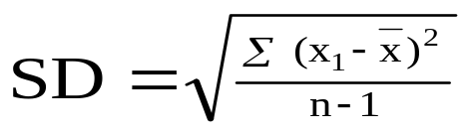  The number of independent data points (values) in a data set are represented by “n” Calculating the mean reduces the number of independent data points to n – 1. Dividing by n-1 reduces bias.  To better understand the concept of SD, see the example in Annex A, and Activity Sheet 7-1.
Calculating acceptable limits for the control | The values of the mean, as well as the values of + 1, 2, and 3 SDs are needed to develop the chart used to plot the daily control values.  - To calculate 2 SDs, multiply the SD by 2 then add and subtract each result from the mean.  - To calculate 3 SDs, multiply the SD by 3, then add and subtract each result from the mean.  If the data has a mean of 190.5 and an SD of 2, then:  + 1 SD is 188.5 - 192.5  + 2 SD is 186.5 - 194.5, and  + 3 SD is 184.5 - 196.5.  For any given data point 68.3% of will fall between + 1 SD, 95.5% between + 2D, and 99.7% between + 3 SD of the mean.  Once these ranges are established, they can be used to evaluate a test run. For example, if you examine a control with your patients’ samples and get a value of 193.5, you know there is a 95.5% chance that it is within 2 SD of the mean.  When only one control is used, we consider a examination run to be “in control” if a value is within 2 SD of the mean.

Coefficient of variation | The coefficient of variation (CV) is the standard deviation (SD) expressed as a percentage of the mean.  CV (%) = SD x 100  Mean  The CV is used to monitor precision. When a laboratory changes from one method of analysis to another, the CV is one of the elements that can be used to compare the precision of the methods. Ideally, the value of the CV should be less than 5%.
Content Sheet 7-4: Graphically Representing Control Ranges

Using graphs for analysis and monitoring | Once the appropriate range of control values has been established, the laboratory will find it very useful to represent the range graphically for the purpose of daily monitoring. The common method for this graphing is the use of Levey-Jennings charts.
Developing data for Levey-Jennings charts | In order to develop Levey-Jennings charts for daily use in the laboratory, the first step is the calculation of the mean and standard deviation of a set of 20 control values as explained in Content sheet 7-3.
Levey-Jennings chart | A Levy-Jennings chart can then be drawn, showing the mean value as well as plus/minus ( + ) 1, 2, and 3 standard deviations (SD). The mean is shown by drawing a line horizontally in the middle of the graph and the SD are marked off at appropriate intervals and lines drawn horizontally on the graph as shown below.  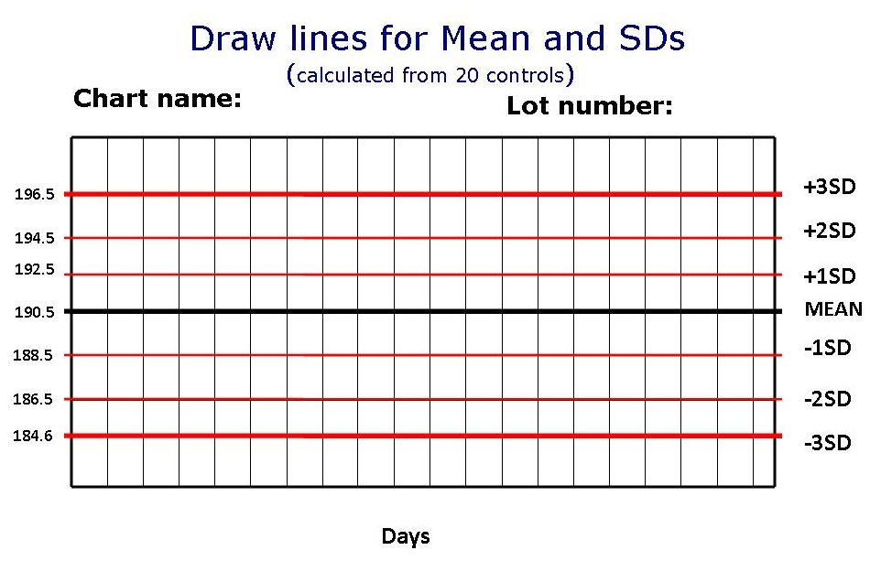  This Levey-Jennings chart was developed using 20 repeated measurements of the control value. In order to use the Levey-Jennings chart to record and monitor daily control values, label the x-axis with days, runs, or other interval used to run QC. Label the chart with the name of the test and the lot number of the control being used.

Content Sheet 7-5: Interpreting Quality Control Data

Plotting control values | A quality control sample tested along with patient’s samples can now be used to determine if daily runs are “in control”. A control sample must be run with each set of patient samples.  Run the control and plot it on the Levey-Jennings chart. If the value is within your accepted control limits, the run can be accepted as “in-control”.  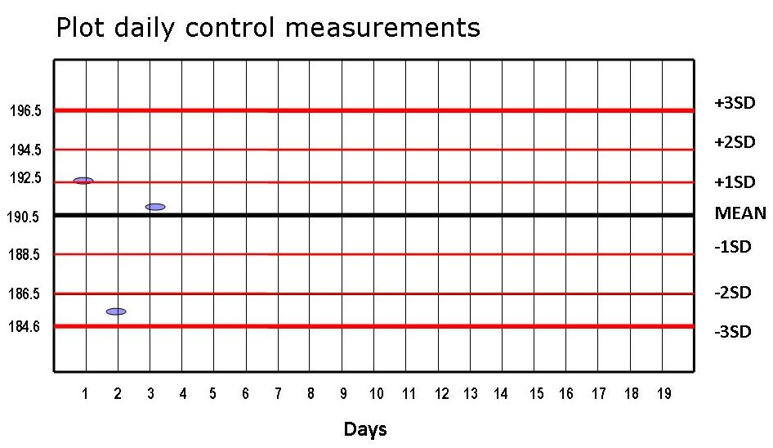  The values on the chart are those run on days 1, 2, and 3 after the chart was made.
Number of controls used | When evaluating results using the within + 2 SD system, the value will be falsely rejected 4.5% of the time.  In order to improve efficiency and accuracy, a system using two or three controls for each run can be employed. Then, another set of rules can be used to avoid rejecting runs that may be acceptable. These rules were applied to laboratory QC by a clinical chemist named James Westgard. This Westgard Multirule System requires running two controls of different target values for each set of examinations, developing a Levey-Jennings chart for each, and applying the rules.  The use of three controls with each run gives even higher assurance of accuracy of the test run. When using three controls, choose a low, a normal, and a high range value. There are also Westgard rules for a system with three controls.
Detecting error | Errors that occur in the testing process may be either random or systematic.  With random error, there will be a variation in quality control results that show no pattern. This type of error generally does not reflect a failure in some part of the testing system, and is therefore not like to reoccur. Random error is only a cause for rejection of the test run if it exceeds + 2 SD.  Systematic error is not acceptable, as it indicates some failure in the system that can and should be corrected. Examples of evidence of systematic error include:  - Shift–when the control is on the same side of the mean for five consecutive runs.  - Trend–when the control is moving in one direction, and appears to be heading toward an out-of-control value.
Shifts and trends | Even when a control value falls within 2 SD, it can be a cause for concern. Levey-Jennings charts can help distinguish between normal variation and systematic error.  Shifts in the mean occur when an abrupt change is followed by six or more consecutive QC results that fall on one side of the mean but typically within 95% range as if clustered around a new mean. On the sixth occasion this is called a shift and results are rejected.  Trends occur when values gradually, but continually, move in one direction over six or more analytical runs. Trends may display values across the mean, or they may occur only on one side of the mean. On the sixth occasion, this is determined to be a trend and results are rejected.  The source of the problem must be investigated and corrected before patients’ samples are reported.
Measurement uncertainty | As variation occurs in measurements, uncertainty exists as to the true value. Uncertainty represents a range of values in which the true value is reasonably expected to lie. In most situations, measurement uncertainty is estimated at “95% coverage.” For most instances, a range of + 2 SD is accepted as measurement uncertainty that is explained by random variation.  But the degree of variation also depends on the method used. Methods that are more precise have less uncertainty because the amount of variation included in the 95% limits is smaller.  Laboratories should strive to use methods that have a high degree of precision, and always follow standard operating procedures.

Content Sheet 7-6: Using Quality Control Information

When QC is out of range | When the quality control sample that is used in a test run is out of the acceptable range, the run is considered to be “out of control”. When this happens, there are several steps that the laboratory must follow.  - The testing process should be stopped, and the technologist must immediately try to identify and correct problems.  - Once possible sources of error have been identified, and corrections have been made, the control material should be re-checked. If they read correctly, then patient samples, along with another quality control specimen, should be repeated. Do not simply repeat the testing without looking for sources of error and taking corrective action.  - Patient results must not be reported until the problem is resolved and the controls indicate proper performance.
Problem solving | When attempting to solve quality control problems, it is useful to have established policies and procedures for remedial action. Often, manufacturers of either equipment or reagents will provide guidelines that can be helpful. Use any troubleshooting guides that are available.  Possible problems to consider include:  - degradation of reagents or kits  - control material degradation  - operator error  - failure to follow manufacturer’s instructions  - an outdated procedure manual  - equipment failure  - calibration error.

Content Sheet 7-7: Summary

Summary | A quality control program for quantitative tests is essential to assuring accuracy and reliability of laboratory testing. The laboratory must establish a quality control program that monitors all quantitative tests. The program will have written policies and procedures that are followed by all laboratory staff.  The overall responsibility of managing the quality control program is usually assigned to the quality manager, who monitors and reviews all quality control data on a regular basis. The recording of the quality control data must be complete and easy to access.  For quantitative testing, statistical analysis can be used for the monitoring process, and the use of Levey-Jennings charts provides a very useful visual tool for this monitoring.  When controls are out of range, corrective action and trouble shooting must be undertaken; the problem must be fixed before reporting patient results. Therefore, good protocols for troubleshooting and corrective action are an important of the quality control process.
Key messages | - A quality control program allows the laboratory to differentiate between normal variation and error.  - The quality control program monitors the accuracy and precision of laboratory assays.  - The results of patient testing should never be released if the quality control results for the test run do not meet the laboratory target values.

Reproduced from Current Laboratory Practice Series. (2009) Laboratory Quality Management System Training Toolkit.

