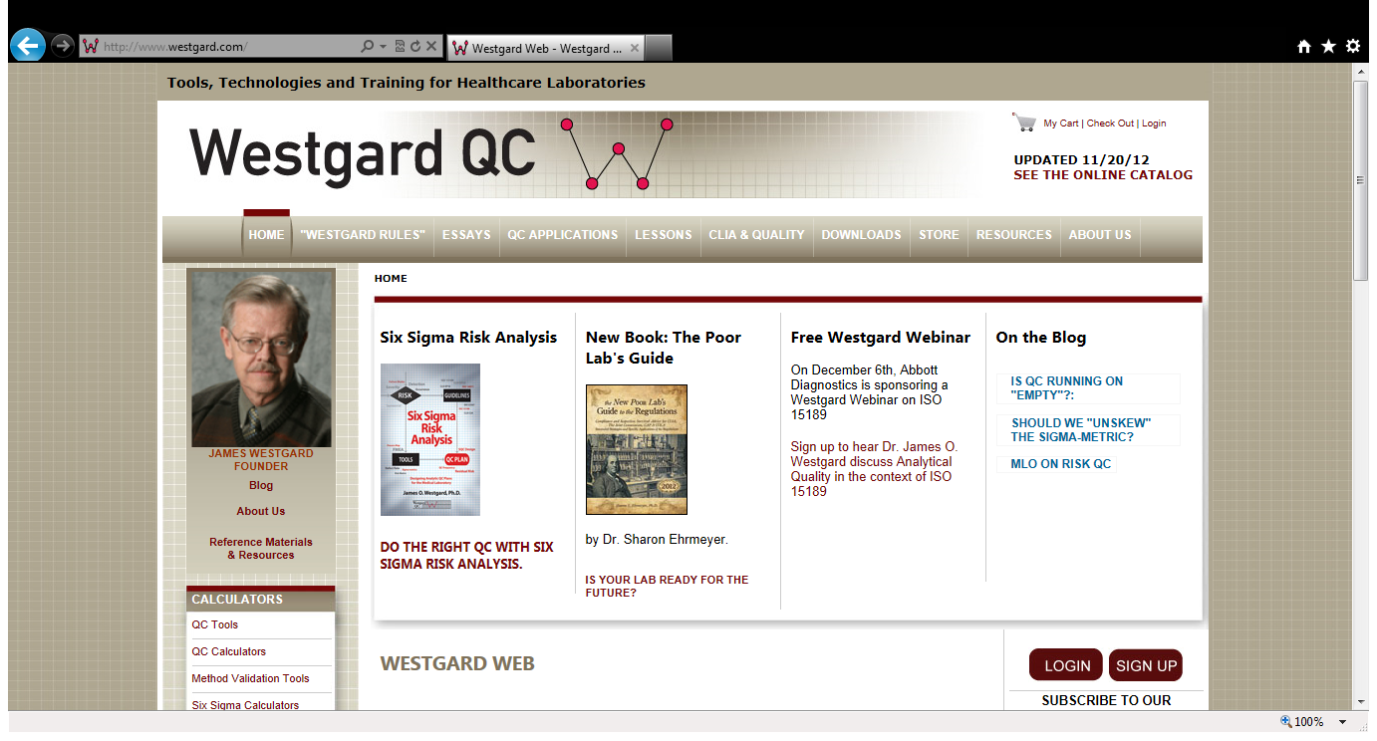

Under the *CLIA & QUALITY* tab and *Quality Requirements* listing, you will find the tables for TEA for biological variation (desirable, minimum, and optimal) and CLIA values used in the workshop

Under the *LESSONS* tab you will find listings for *Basic QC Practices* and *Basic Method Validation*.

On the HOME page, the area to perform searches is located below the LOGIN area. For other pages, the area is located on the right side of the page

Under the *DOWNLOADS* tab, you will find free book review chapters, calculators and worksheets. The Sigma-metric QC Selection Tool and Westgard Rule worksheets used in the workshop are located under *Worksheets.*

Initially, you will need to register and create a login. Membership is free.

SEE BELOW

**search…**

Remember your login name and password so that you can access the entire site. You can logoff from this site by pressing any tab. The LOG OUT message will appear on the right

QC calculators allow you to calculate your mean, SD, %CV, and cumulative statistics

Another area you can login to the site.

