

Directions:

Using the assigned mean and SD provided, calculate the control limits. On the Y-axis, write those numerical values on the appropriate line.

Plot data points 21 to 30.

Visually assess the completed L-J chart before answering the questions.

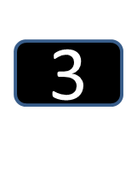

Based on the visual pattern and not QC rules,

1. Do the data in runs 21 to 30 show a change in accuracy? YES / NO
2. Do the data in runs 21 to 30 show a change in precision? YES / NO

Complete the following for data runs 21-30 only

68% of the data points lie between ________ and ________.

95% of the data points lie between ________ and ________.

What QC Rule(s) are violated on the graph?

|  |  |  |
| --- | --- | --- |
| **Run Number** | **Rule(s) Violated** | **What Type of Error (SE or RE)** |
|  |  |  |
|  |  |  |
|  |  |  |
|  |  |  |

Do the rules violated support your visual assessment?

On the back of this page, draw the Gaussian curve of the population(s) represented by this L-J chart.