Job aid: European federation of Clinical Chemistry and Laboratory Medicine (EFLM) website navigation for Biological Variation quality goals.
It is important to read all information provided prior on deciding on the Biological variation goals provided.

APS = Analytical performance specifications
BIVAC = Biological variation Data Critical Appraisal Checklist
CVa = analytical CV
CVI = % Within subject
CVG = % Between subject
Mau = Measurement uncertainty
TEa = Total allowable error

EFLM website
- Go to internet browser and type in EFLM Biological Variation Database. https://biologicalvariation.eu/

- Read the background information explaining the process. https://biologicalvariation.eu/background

- You can search directly for an analyte in the search box or open Global BV estimates , see circled below.

- The All BV data sets will provide you with the list of references and BIVAC datasets by Measurand per measurand and what data sets were included or excluded e.g Glucose has 66 datasets. 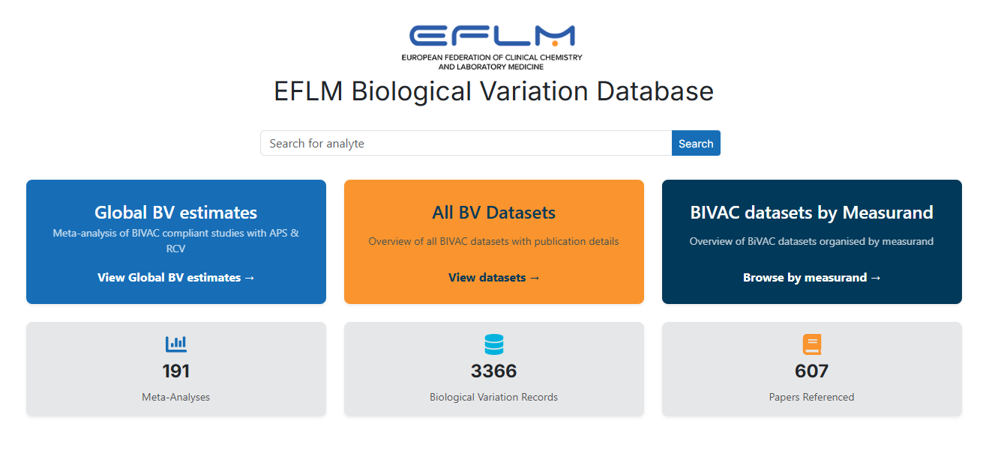

- Glucose will be used as an example. Once analyte chosen, there are filters for Data type.
- The following shows the BV estimates for within and between subjects with lower and higher confidence intervals. Click on Analytical performance specification block circled below

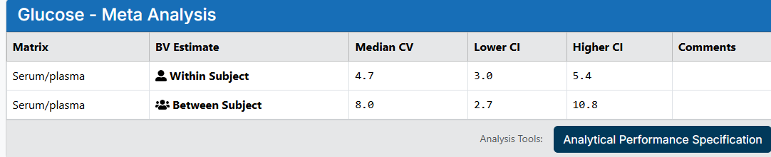
- The values will appear, these values can be changed if required and press calculate circled below
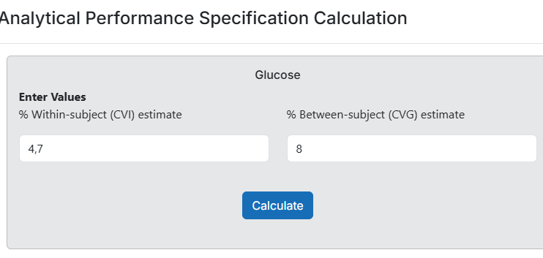

- The following results will appear. It is recommended to use Desirable goals to begin with. 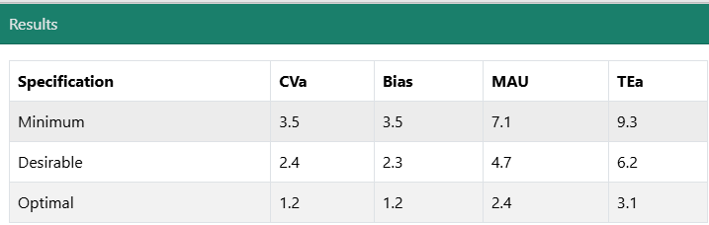
- See below for the explanation of each column.

There are currently three main models for calculating analytical performance specifications (APS)
- direct- and indirect outcome studies
- Biological variation
- State-of-the-art
In the EFLM BV database, APS based on biological variation (BV) data are presented.
BV-based APS are commonly used for measurands that have a stable concentration/activity. Users of the data from this site should make themselves aware of the confidence limits around the published BV estimates and assure themselves that the data presented are safely transportable as reference data applicable to their local populations and practice.
Be aware that some currently available BV estimates may be based on limited data sets and therefore can be uncertain.

The background for the formulas presented below is given in Clin Chem Lab Med 2024;62:1483–9.

Imprecision
CVA < 0.5 × CVI
The factor 0.5 refers to desirable APS.
The factor for optimum and minimum performance specifications are arbitrarily set to 0.25 and 0.75 respectively.

Bias
Bias < 0.25 × (CVI² + CVG²)¹/²
The formula for bias is intended to be used for laboratories to enable use of the same reference limits. The factor 0.25 refers to desirable APS. The factor for optimum and minimum performance specifications are 0.125 and 0.375, respectively. The formula assumes that imprecision is close to zero. When this is not the case, the factors must be lower, see reference above.

Total allowable error (TEa)
TE < 1.65 × (0.5 × CVI) + 0.25 × (CVI² + CVG²)¹/²
The total allowable error (TEa) formula that considers both bias and imprecision was developed for EQA organizers and has been widely applied since it is easy to use.
However, this conventional model for deriving TEa from BV sums up two mutually exclusive terms, i.e., maximum allowable bias and maximum allowable imprecision, resulting in an overestimating TEa. For these reasons, this approach should be applied with caution.

MAu
MAu < 2 × 0.5 × CVI
Bias should, in principle, be eliminated and all the remaining sources of variation added linearly as variances. A measurement result therefore can comprise two uncertainties: the uncertainty associated with bias correction and the uncertainty due to imprecision. Accordingly, the maximum allowable standard measurement uncertainty (MAu) can be set as 0.5 x CVI, and the maximum expanded allowable measurement uncertainty (MAU) will be k x 0.5 x CVI. The “k” is the coverage factor, for example, 2 or 3, to obtain a certain confidence level (95 or 99). The most used coverage factor is 2. Thus, MAU can be calculated as above
The factor 0.5 refers to desirable APS. The optimum and minimum performance specifications factors are arbitrarily set to 0.25 and 0.75, respectively.

Reference
https://biologicalvariation.eu/meta_calculations

