Target Value
Lower TE_{A} Limit
Target Value - TE_{A}
Target Value +TE_{A}
Upper TE_{A} Limit

Directions: For each problem, calculate the lower and upper TE_{A} limits with the information provided. Complete the diagrams.
- Percentage (%) The CLIA TE_{A} for chloride is Target Value ± 5%.

 | QC Material | Target Value | TE_{A} in units | Lower TE_{A} Limit | Upper TE_{A} Limit
Chloride | Level I | 100 mmol/L
 | Level II | 120 mmol/L

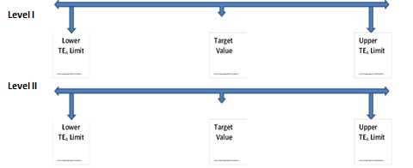

- Absolute concentration limit The CLIA TE_{A} for potassium is Target Value ± 0.5 mmol/L.

 | QC Material | Target Value | TE_{A} in units | Lower TE_{A} Limit | Upper TE_{A} Limit
Potassium | Level I | 3.5 mmol/L
 | Level II | 5.8 mmol/L

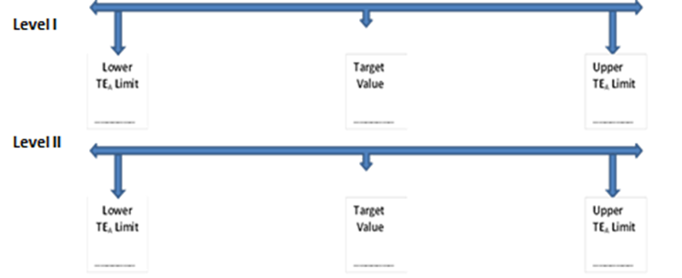

- Distribution of a survey group The CLIA TE_{A} for TSH is Target Value ± 3SD.
Results from most recent TSH survey. Values are reported in mU/L unless otherwise specified
Sample | Mean | SD | %CV
C-1 | 0.6 | 0.05 | 8.3%
C-2 | 1.0 | 0.08 | 8.0%
C-3 | 1.2 | 0.08 | 6.7%
C-4 | 3.0 | 0.26 | 8.7%
C-5 | 4.2 | 0.33 | 7.9%

 | QC Material | Target Value | TE_{A} in units | Lower TE_{A} Limit | Upper TE_{A} Limit
TSH | Level I | 0.90 mU/L
 | Level II | 4.50 mU/L

- Combination of requirements, percentage and absolute concentration units (for lower concentrations)
The CLIA TE_{A} for glucose is Target Value ± 0.3 mmol/L or ± 10%, whichever is greater.

 | QC Material | Target Value | TE_{A} in units | Lower TE_{A} Limit | Upper TE_{A} Limit
Glucose | Level I | 2.78 mmol/L
 | Level II | 5.72 mmol/L

- There is no published TE_{A} limit, you decide to use a recent survey report for CD₄ and multiply the peer group median %CV by a factor of 3.

Results from most recent CD₄ survey. Values are reported in cell/uL unless otherwise specified.

Sample | Mean | SD | %CV
C-1 | 287.5 | 21.0 | 7.3%
C-2 | 850.1 | 41.6 | 4.9%
C-3 | 61.0 | 4.1 | 6.7%
C-4 | 771.4 | 40.1 | 5.2%
C-5 | 162.0 | 9.7 | 6.0%

CD4 | QC Material | Target Value | TE_{A} in units | Lower TE_{A} Limit | Upper TE_{A} Limit
 | Level I | 50 cell/uL
 | Level II | 200 cell/uL
 | Level III | 700 cell/uL

