Directions: Calculate the SDI and Limits of Acceptability. Based on the acceptable range, determine your grade for the survey sample. The first two rows are completed for you.
CLIA acceptable performance for free thyroxine is Target Value ± 3SD of the PT group.
Test  Unit of Measure  Peer Group | Evaluation and Comparative Method Statistics
 |  |  |  |  |  |  | Limits of Acceptability
 | Sample | Your Result | Mean | SD | N | S.D.I | Lower | Upper | Your Grade
Free Thyroxine (ng/dl) | CH-01 | 4. 5 | 4.64 | 0.26 | 45 | (4.5-4.64)/0.26 = - 0.5 | 4.64 – 3(0.26) =3.86 | 4.64 + 3(0.26) = 5.42 | acceptable
Siemens Advia Centaur, XP | CH-02 | 2.4 | 2.66 | 0.19 | 59 | (2.4 – 2.66)/0.19 = -1.4 | 2.66 – 3(0.19)  = 2.09 | 2.66 + 3(0.19) =3.23 | acceptable
Siemens Advia Centaur rgt | CH-03 | 1.0 | 1.13 | 0.08 | 45
 | CH-04 | 1.8 | 2.07 | 0.14 | 33
 | CH-05 | 2.2 | 2.37 | 0.12 | 45

The survey sample CH-01 is above / below the group’s mean (target value). Your result is _______ group SDs from the peer group’s mean.
Circle one
The survey sample CH-02 is above / below the group’s mean (target value). Your result is _______ group SDs from the peer group’s mean.
Circle one
The survey sample CH-03 is above / below the group’s mean (target value). Your result is _______ group SDs from the peer group’s mean.
Circle one
The survey sample CH-04 is above / below the group’s mean (target value). Your result is _______ group SDs from the peer group’s mean.
Circle one
The survey sample CH-05 is above / below the group’s mean (target value). Your result is ________ group SDs from the peer group’s mean.
Circle one
SDI enables your laboratory to assess your performance in the context of peer laboratories. Even though the performance is satisfactory for this analyte, your assessment of free thyroxine testing may indicate a problem with (_____ accuracy) (____ precision) for your laboratory.
check all that apply

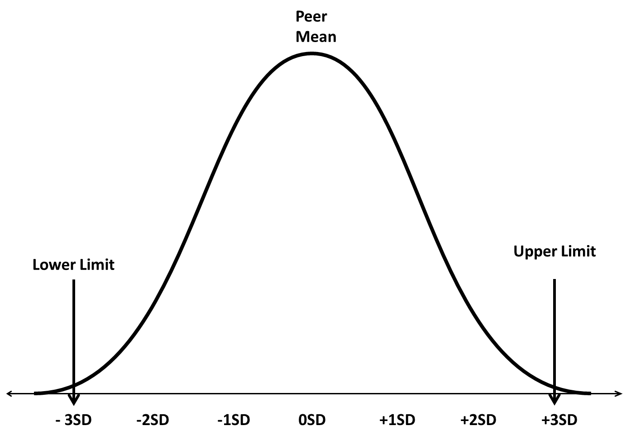
CH-02
CH-01
Using the SDI calculated for each survey sample, draw a circle to indicate the location of your survey samples in relationship to the peer group’s mean. CH-01 and CH02 are done for you.

